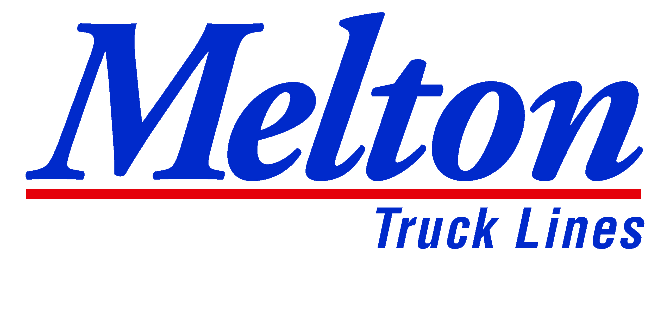
808 N. 161st East Ave.
Tulsa, OK 74116

FOR IMMEDIATE RELEASE

Melton Truck Lines, Inc. Announces Largest Driver Pay Increase in Company History

TULSA, OK – June 2, 2021 - Melton Truck Lines, a premier air-ride flatbed carrier based in Tulsa, OK, is pleased to announce a driver pay increase. All company drivers will receive some sort of increase. Melton’s pay scale still varies depending on experience and tenure. This increase will start student drivers at 47 CPM and will give the most experienced drivers 63 CPM. Melton’s base pay increase keeps the company in the top industry pay scale according to the National Survey of Driver Wages.
In February 2021, Melton increased tarp pay from $50 to $100; far surpassing other flatbed carriers in the industry. Along with this increase, Melton drivers will be presented with numerous opportunities to earn additional pay. Melton’s $5,400 fuel bonus, additional 16 CPM pay for over-dimensional loads, extra 6 CPM pay for Canada and Hazmat loads, and various other opportunities.
Chairman and CEO Bob Peterson states, “I’m so proud of our drivers’ unmatched bravery and dedication to the job, especially throughout this past year. They truly drive our company’s success, and we are pleased to offer a stable, highly rewarding career path. Given the current freight environment and gradual recovery from the pandemic, we are excited for what the rest of this year has in store. With industry-wide driver hiring challenges, we find our new pay package far exceeds other carriers when accounting for our $100 tarp pay, bonus pay, and additional opportunities. We know Melton flatbed drivers are the best in the country and deserve every penny. We will continue to maintain a culture of safety, professionalism and most of all – family – where everyone goes the extra mile to be exceptional.”

Company Information
Headquartered in Tulsa, OK, Melton Truck Lines Inc. is an award-winning leader in the air-ride flatbed industry and services the United States, Canada, and Mexico. In business for over 67 years, Melton has offices and terminals in Tulsa, Laredo, El Paso, Birmingham, and Masury, OH along with a business and sales office in Monterrey, Mexico. For more information, please visit meltontruck.com.

###

