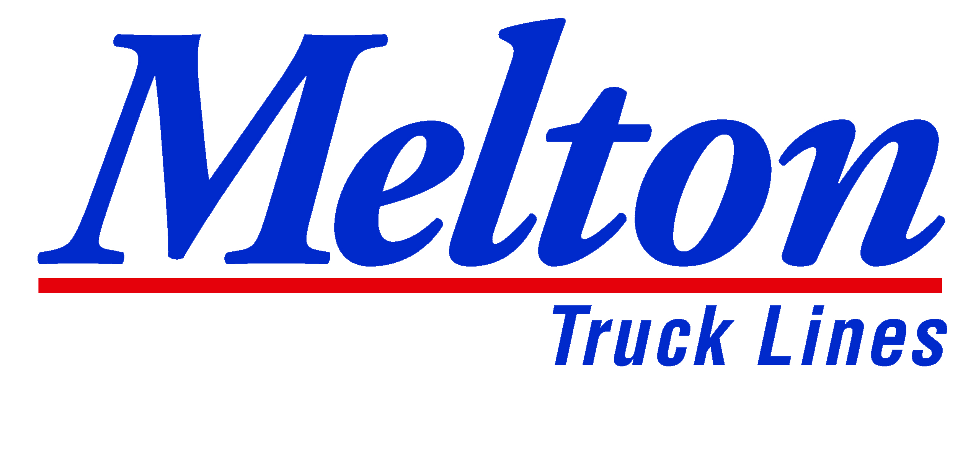
808 N. 161st East Ave.
Tulsa, OK 74116

FOR IMMEDIATE RELEASE

Melton Truck Lines, Inc. Announces Additional 2021 Driver Pay Increase

TULSA, OK – November 1, 2021 - Melton Truck Lines, a premier air-ride flatbed carrier based in Tulsa, OK, is pleased to announce an additional driver pay increase in 2021. All company drivers will receive some sort of increase. Melton’s pay scale still varies depending on experience and tenure. This increase will start student drivers at 52 CPM and will give the most experienced drivers 65 CPM. The increase will go into effect November 16th for all incoming and current drivers. Melton’s base pay increase keeps the company in the top industry pay scale according to the National Survey of Driver Wages.
In June 2021, Melton announced their largest driver pay increase in company history, shortly after announcing their new $100 tarp pay – Far surpassing other flatbed carriers in the industry. In addition to this increase, Melton drivers will have numerous opportunities to earn additional pay. Melton’s $5,400 fuel bonus, recently increased orientation and training pay, driver referral bonuses, additional 16 CPM pay for over-dimensional loads, and various other opportunities.
“In a year where most industries are struggling to find workers, we are very fortunate to have our fleet of hard-working, dedicated drivers and we appreciate all of them,” said Melton’s Executive Vice President & Chief Operating Officer, Russ Elliott. “Driver Appreciation is not only one of our core values and stated traditions but is also a tremendous factor in every decision we make. Thanks to driver feedback, we are able show our appreciation by making big changes that matter to them. Just this year, we doubled tarp pay from $50 to $100, announced a 20% driver base pay increase, and quadrupled our average driver referral bonus. Our employees’ continued efforts to work safely and productively enables us to give another well-deserved increase to our drivers!”

Company Information
Headquartered in Tulsa, OK, Melton Truck Lines Inc. is an award-winning leader in the air-ride flatbed industry and services the United States, Canada, and Mexico. In business for over 67 years, Melton has offices and terminals in Tulsa, Laredo, El Paso, Birmingham, and Masury, OH along with a business and sales office in Monterrey, MX. For more information, please visit meltontruck.com.

###

